# Login

To login to the downloader application, enter your username and password into the login screen and select the “Log Me In” button.

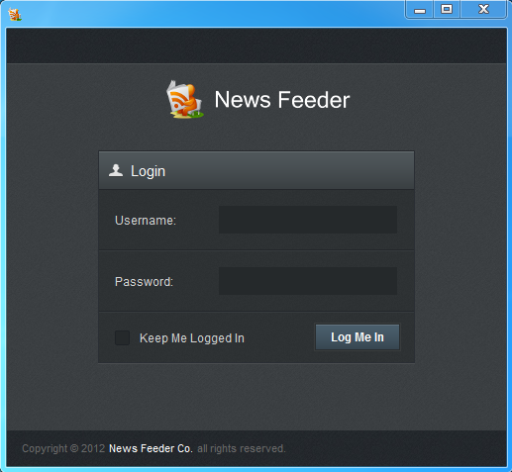

An option is provided on the login screen for staying logged in. This will allow automatic login when opening the application in the future.

On login, your credentials will be authenticated with the News feeder Web Service. This means that your username and password will be the same for the Downloader application as what is used on the website.

If you have not registered for an account to use with the downloader application, you can register by going to the website here: <http://newsfeeder.co/members/register/>

# The Task Tray

## Opening From the Task Tray

When closing the Downloader application by selecting the top cross, the application will not completely close. Instead, the downloader will run in the background.



You can re-open the application and pick up where you left off by either:

1. Double click the News feeder logo in the task tray
2. Right click and select the show button in the task tray

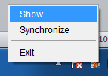

## Synchronize

The task tray allows you to perform a manual synchronize with the News feeder database. The Synchronize will connect to the web service and pull down the latest sheet information. To synchronize, right click on the News feeder icon and select Synchronize.

A synchronize is performed on a regular basis (every 5 minutes) so a synchronize button is provided for convenience.

## Exit

The exit button provides a way to exit the application. To exit the application, right click on the News feeder icon and select Exit.

# News Feeder Sheets

The main view of the downloader application provides a way to view the sheet content in offline mode. From the drop down in the top right corner, you can select a sheet to view, your default sheet used online will be the default sheet used in the application.

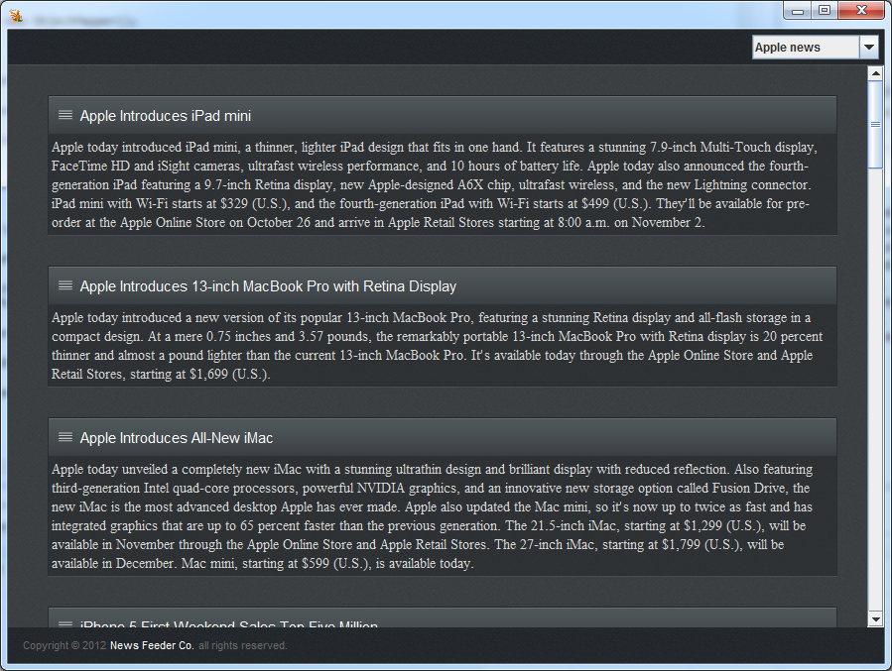

News content containing links will open in your favourite browser, and layouts created and used on the website will render similar in the downloader application creating a seamless look and feel between the two applications.